# Christmas Cheer Laser, part 4

## Get-Help (alias help)

Since we are going to use the Sort-Object cmdlet, we might as well learn a little about it. Search engines are most people’s primary tools for learning about commands, but PowerShell also includes a help cmdlet called Get-Help. The full help is not installed by default on Windows machine. To add it, use Update-Help from an elevated terminal (Administrator.)  
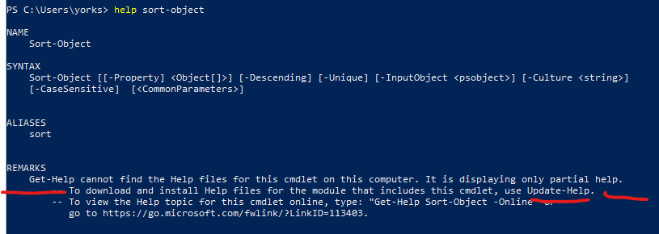

Unfortunately, this only works on your own host where you have administrator access. We are using someone else’s terminal, so we will not be able to install the full help. (I just thought you should know about it.)

## Sort-Object (alias sort)

In the help screen above, we see that Sort-Object wants a parameter [[-Property] <Object[]>] to sort on. The square brackets denote something that is optional, so we could have no parameters and let the cmdlet sort on whatever it wanted to (usually name.) That is silly, so we would use  
Sort-Object -Property LastWriteTime  
for example. Note that -Property is also inside square brackets. This means that -Property is a positional parameter. It is used so often that the cmdlet will assume you mean   
-Property even if it is not present. You can save typing by using  
Sort-Object LastWriteTime or even sort LastWriteTime .

If you want to reverse the sort order, you use -Descending.

Note: When you see something[] in the help file, that means that the cmdlet can accept an array of somethings.

## Select-Object (alias select)

We will talk more about Select-Object later, but it has useful parameters that will help us now. When you have a lot of output and you only want to see the beginning or end of the data so your screen doesn’t fill up, pipe your output into Select-Object -First (or -Last.) You can control how many lines you see by giving it a number; Select-Object -First 10 will show the first 10 lines. This is like the Linux head command. The Linux tail is like -Last.

## Answer to the Previous Question

1. What riddle do you find inside the archive?  
   We can do a variation of the command above, but it has problems.  
   dir /etc -Recurse | sort LastWriteTime -Descending  
   There is a lot of data that scrolls off the top of the screen, and there is nasty red error text. The reason for the error is that the Get-ChildItem (dir) cmdlet tried to look in places where it didn’t have permission.  
   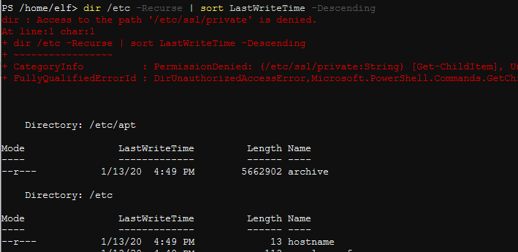  
   We can remove the error text by telling PowerShell to ignore it. We add this:  
   -ErrorAction SilentlyContinue  
   To just see the first line of the result, we can pipe into Select-Object (alias select) with the -First 1 option. Since the command is long, I hit Enter after the pipe, and PowerShell allowed me to continue.  
   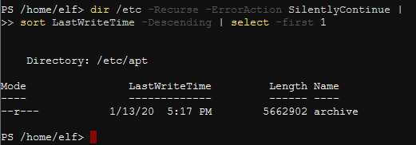  
   Success!  
   To expand the archive we use, surprise, Expand-Archive. In its long form the command would be  
   Expand-Archive -Path /etc/apt/archive -DestinationPath ./archive  
   or in short form  
   Expand-Archive /etc/apt/archive ./archive  
   Let’s see what we expanded.  
   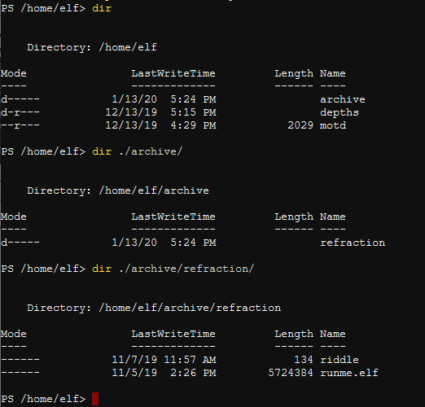  
   They are making us work, for sure. Remember the runme.elf file—we’ll need to come back to that. The .elf extension normally indicates a Linux executable file.  
   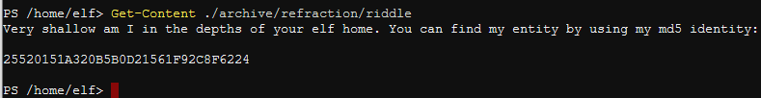

Another option in Get-ChildItem (dir) to go with -Recurse is -Depth, and it specifies how many subdirectory levels to look at. You can use -Depth without -Recurse.

PowerShell has a cmdlet to take hashes of files, and it can use several different algorithms.

## Where-Object (aliases where and ?)

Using the Where-Object cmdlet is like putting an if statement in the middle of the pipeline. Objects which meet the requirements of your test continue down the pipeline; those which do not are dropped. The general syntax is  
some objects | Where-Object {someTest -eq True} | true, keep on going.

Note that the test is enclosed in curly braces, which denote a script block. Also note that the comparison operators are things like -eq, -ne, -gt, and the like. See this site for a list of operators: <https://docs.microsoft.com/en-us/powershell/module/microsoft.powershell.core/about/about_comparison_operators?view=powershell-7>

Another useful thing when using the pipeline is the $_ automatic variable. I think it was taken from Perl, and the concept is simple; it refers to whatever object was passed down the pipeline. You can reference properties of that object with $_.property. For example, if you are only interested in services that are stopped, you could do this.  
Get-Service | Where-Object {$_.Status -eq "Stopped"}  
Get-Service puts an object into the pipeline for every service. The Where-Object cmdlet only lets those that have a Status of Stopped continue.

## Question

1. Do a search of /home/elf to a “shallow” depth. Compute the MD5 hash of all the files you find, and output the name and path of the file that has a hash of 25520151A320B5B0D21561F92C8F6224